How to Find Workday Position IDs
For filled positions only:

- In Workday, navigate to the worker profile by typing the worker’s name in the search bar at the top of the screen and selecting the worker from the list of results.
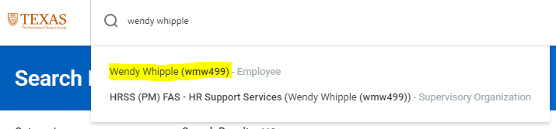
- When on the worker profile, click the Job tab on the left hand side.
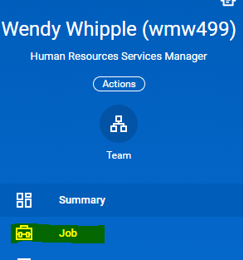
- Then select the All Jobs tab on the top of the page.
- Then scroll down on this page and you will see a table like the one pictured below. It will include the Position ID for the position the worker is in.
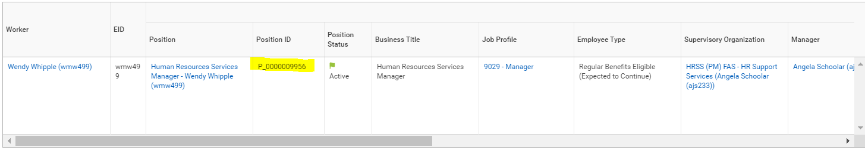

For both filled and vacant positions:

- Position IDs for both filled and vacant positions can be found by running reports. In Workday, run report “All Positions for Supervisory Organization- RPT0462” and the results will include position IDs.
